Lab # 2
Lab Tasks:

- Write a python code to load an excel spreadsheet containing two different sheets and print both of them.
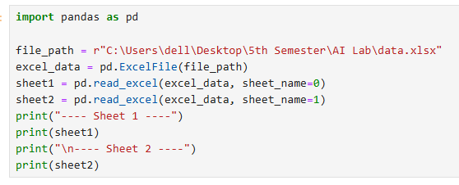

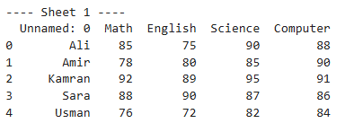

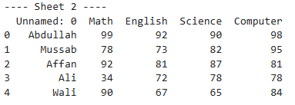

- Write a python cade to generate a pandas data frame having 4 columns and 5 rows. Column 1 must contain the index values like Ali, Amir, Kamran, etc and Row 1 must contain the subject names.

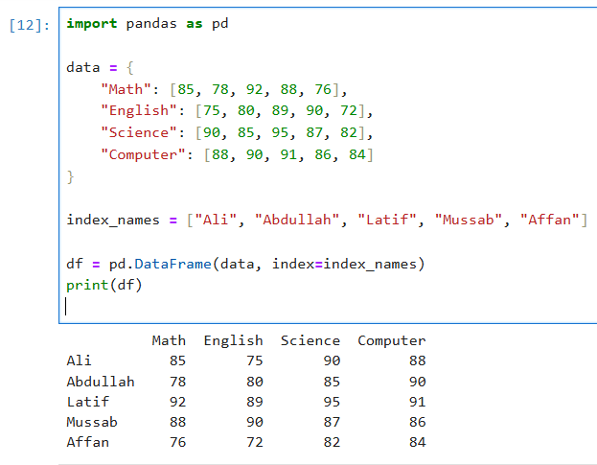

- Write a python code to read an excel spreadsheet and only print first two columns using pandas data frame.
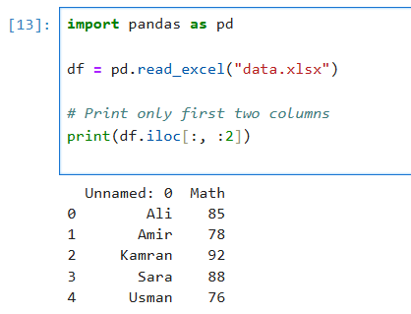

- Write a python code to skip the first two rows of excel spreadsheet and print the output using pandas data frame.

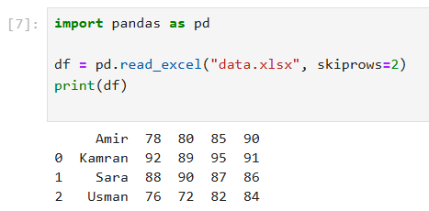

- Write a python code to fill all the null values in Gender column of employees.csv with “No Gender”. Print the first 10 to 30 rows of the data frame for visualization.
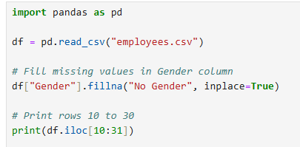
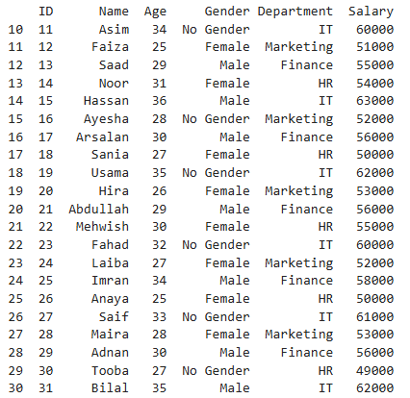
- Write a python code to scale the values of features (Age and Salary) using Min-Max Normalization technique. Verify your answers by applying the formula mentioned above.
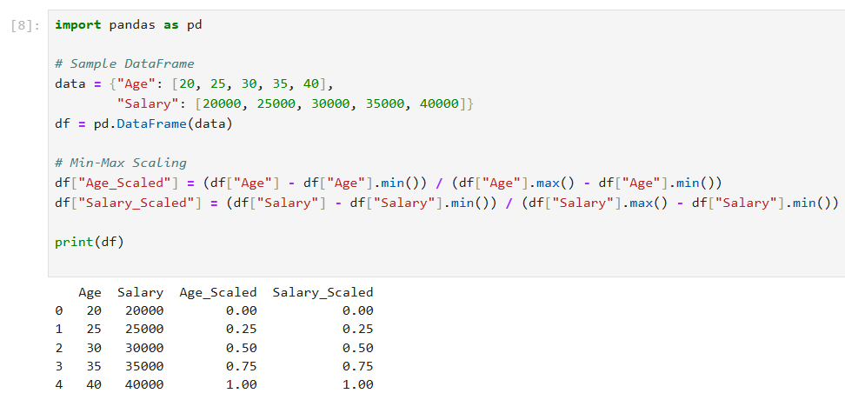

- Given this dictionary, create a dataframe from dictionary and interpolate the missing values using backward interpolation. Hint: use interpolate().

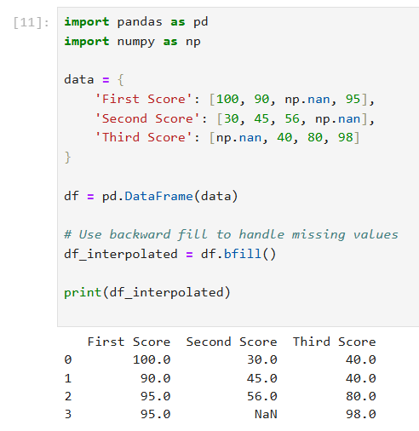

- Write a python code to scale the values of features (Age and Salary) using Standardization technique. Verify your answers by applying the formula mentioned above.

